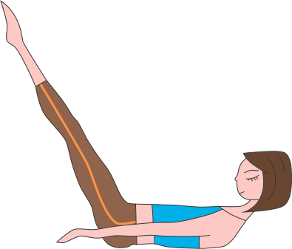
Pilates
Rejuvenation & Wellness

Waiver of Liability Relating to Coronavirus/COVID-19

The novel coronavirus, COVID-19, has been declared a worldwide pandemic by the World Health Organization. COVID-19 is reported to be extremely contagious. The state of medical knowledge is evolving, but the virus is believed to spread from person-to-person contact and/or by contact with contaminated surfaces and objects, and even possibly in the air. People reportedly can be infected and show no symptoms and therefore spread the disease. The exact methods of spread and contraction are unknown, and there is no known treatment, cure, or vaccine for COVID-19. Evidence has shown that COVID-19 can cause serious and potentially life threatening illness and even death.

Pilates Rejuvenation & Wellness (“PRW”) cannot prevent you [or your child(ren)] from becoming exposed to, contracting, or spreading COVID-19 while utilizing PRW’s services or premises. It is not possible to prevent against the presence of the disease. Therefore, if you choose to utilize PRW’s services and/or enter onto PRW’s premises you may be exposing yourself to and/or increasing your risk of contracting or spreading COVID-19.

ASSUMPTION OF RISK: I have read and understood the above warning concerning COVID-19. I hereby choose to accept the risk of contracting COVID-19 for myself and/or my children in order to utilize PRW’s services and enter PRW’s premises. These services are of such value to me [and/or to my children,] that I accept the risk of being exposed to, contracting, and/or spreading COVID-19 in order to utilize PRW’s services and premises in person.

WAIVER OF LAWSUIT/LIABILITY: I hereby forever release and waive my right to bring suit against Pilates Rejuvenation & Wellness and its owners, officers, directors, managers, officials, trustees, agents, employees, or other representatives in connection with exposure, infection, and/or spread of COVID-19 related to utilizing PRW’s services and premises.
Waiver of Liability Relating to Coronavirus/COVID-19 page 2

I understand that this waiver means I give up my right to bring any claims including for personal injuries, death, disease or property losses, or any other loss, including but not limited to claims of negligence and give up any claim I may have to seek damages, whether known or unknown, foreseen or unforeseen.

CHOICE OF LAW: I understand and agree that the law of the State of Florida will apply to this contract.

I HAVE CAREFULLY READ AND FULLY UNDERSTAND ALL PROVISIONS OF THIS RELEASE, AND FREELY AND KNOWINGLY ASSUME THE RISK AND WAIVE MY RIGHTS CONCERNING LIABILITY AS DESCRIBED ABOVE:

Signature: _______________________ Date: ________________________

Name (printed): _______________________

